University of Central Punjab

Faculty of Information Technology and Computer Science
Course Title: Software Construction & Development

Assignment 03
Scenario: Parking Fee Calculator using Java Swing

Name: | Muhammad Arham | Registration No.: | L1F23BSSE0372
Section: | SE-E5 | Date:
Course Code: | SESD3242 | Total Marks: | 50
Deadline: | 06-06-2026 | Submission: | Typed / Printed

CLO# | Course Learning Outcome (CLO) | Taxonomy Level | PLO
CLO2 | Apply software design principles, refactoring techniques and design patterns to develop collaborative, maintainable,  and high-quality Java applications. | C3 | 2

Instructions:
- Late submission will cause 20% deduction. No submission after 2 days.
- Assignment should be properly typed and formatted.
- Attach this title page to your submission.
- Evaluation may be viva-based. Students should understand their code.
- Plagiarism is not allowed. Write and explain your own solution.

Question 1:

import javax.swing.*;
import java.awt.*;
import java.awt.event.ActionEvent;
import java.awt.event.ActionListener;
public class Parking_Fee_Calculator extends JFrame implements ActionListener {
JLabel hoursLabel,feeLabel;
JTextField hoursInput,feeOutPut;
JButton generateButton,resetButton;
public Parking_Fee_Calculator(){
setTitle("Parking Fee Calculator");
setSize(500,300);
setLayout(new FlowLayout());
setDefaultCloseOperation(JFrame.EXIT_ON_CLOSE);
hoursLabel=new JLabel("Enter Parking Hours:");
hoursInput=new JTextField(10);
feeLabel=new JLabel("Total Fee (RS):");
feeOutPut=new JTextField(10);
feeOutPut.setEditable(false);
generateButton=new JButton("Generate Fee");
resetButton=new JButton(" Reset");
generateButton.addActionListener(this);
resetButton.addActionListener(this);
add(hoursLabel);
add(hoursInput);
add(feeLabel);
add(feeOutPut);
add(generateButton);
add(resetButton);
setVisible(true);
}
@Override
public void actionPerformed(ActionEvent e) {
if (e.getSource()==generateButton){
String inputText=hoursInput.getText();
try{
if (inputText.isEmpty()){
JOptionPane.showMessageDialog(this,"Please Enter Parking Hours");
return;
}
int hours=Integer.parseInt(inputText);
int fee;
if (hours<=3){
fee=hours*50;
}else {
fee=hours*80;
}
feeOutPut.setText("Rs. "+fee);
} catch (NumberFormatException ex) {
JOptionPane.showMessageDialog(this,"Enter Hours Correctly");
}finally {
JOptionPane.showMessageDialog(this,"Fee Generated SuccessFully");
}
} else if (e.getSource()==resetButton) {
hoursInput.setText("");
feeOutPut.setText("");
}
}
public static void main(String[] args) {
new Parking_Fee_Calculator();
}
}

OutPut:

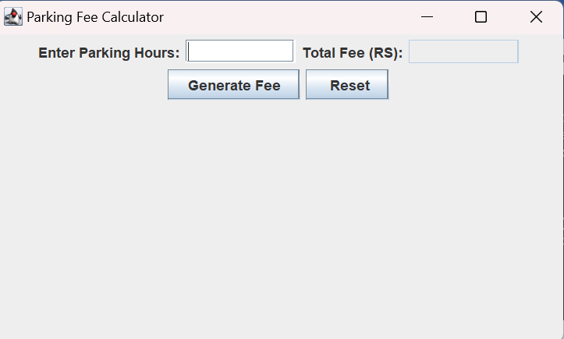

3-Hours:

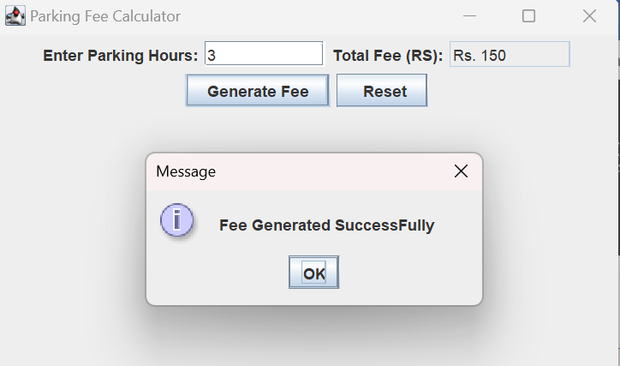

5-Hours:

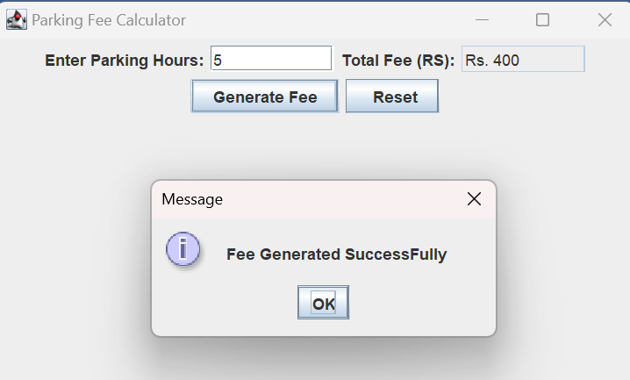

Exception Handling Output:

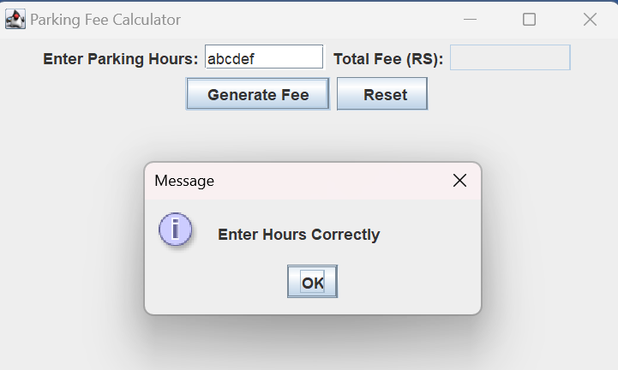

Reset_Button:

